Hello Lucid Supplier,
First, congratulations on being selected as one of Lucid Gravity Part Suppliers! The next step is to prepare to receive demand from Lucid Motors via our 3rd Party True Commerce True Auto Web Portal. This demand will be sent 1-Apr-2024.
You MUST use this portal to receive Gravity Demand and process your Advanced Ship Notices and Invoices to Lucid. The True Auto Portal enables you and Lucid to accurately and timely track your products and be immediately compliant with Lucid’s EDI requirements.
Getting portal access setup, logins distributed, and enrolling your Subject Matter Experts for training requires your focused attention on following True Commerce instructions. It is important to know your operational processes, your systems and True Auto Web Portal must be aligned, or you will not know how to consume our demand and send us accurate, timely ASNs and invoices.
Lucid will be sponsoring the cost for the True Auto Portal for 6 months, Oct 1. After this time, your portal license will either be migrated to your own account or your own EDI system if you desire. You will receive a one-month notice when your license expires to migrate your license or put your EDI system in place.
Some of you are currently in process with True Commerce onboarding to develop your own EDI infrastructure, but you will not be ready by 1-Apr when Lucid sends Gravity demand. You must use the True Auto Web portal to receive initial Gravity demand. Continue to develop your EDI solution in parallel. You can migrate anytime once you and Lucid Motors complete a Readiness Checkpoint, ensuring your operations and systems, and those of Lucid are ready to process EDI messages.
All impacted Gravity suppliers need to:
- Respond swiftly to any requests from the True Commerce Onboarding Team. They will provide you with registration information, assign True Auto logins, and arrange for training sessions. The training sessions will be setup by True Commerce and held on the following dates:
Training will be conducted week of 25-March. True Commerce will provide exact dates in their message for you to prepare for Portal Training.
- Training Webinar Videos will be made available via link on True Commerce Site.
- Download ALL EDI documentation and ENSURE OPERATIONS SMEs (Order Management, Shipping and Logistics, Accounts Receivable) and Systems teams review the material. This ensures your operations can consume and deliver accurate supply chain data in the True Auto Web Portal. Failure to understand this material may result in non-compliant shipments, subject to minimum $1,000 per shipment non-compliance penalties.
  - Download ALL EDI documents via this link:
  - Select Lucid Motors via drop down menu:
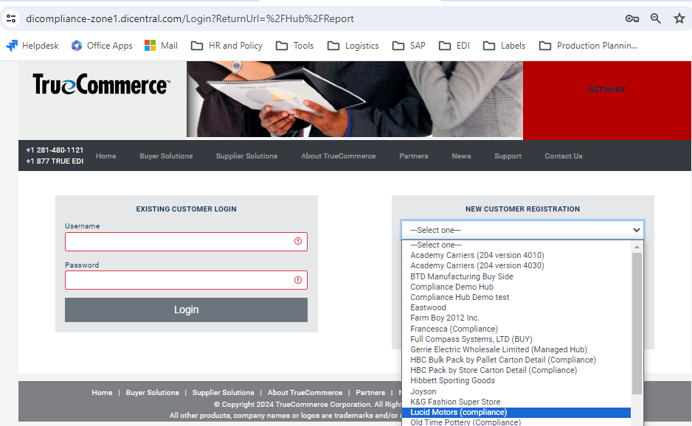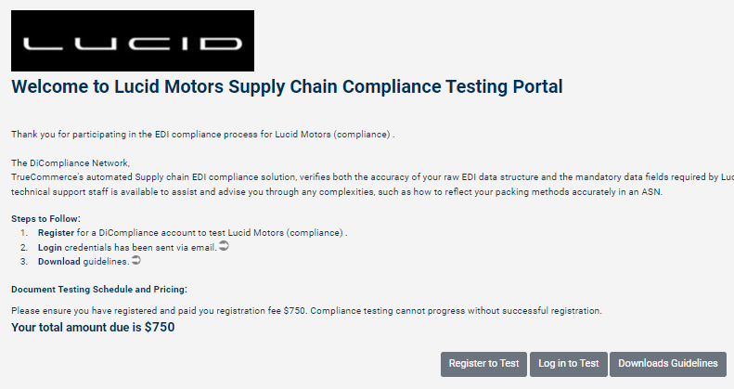
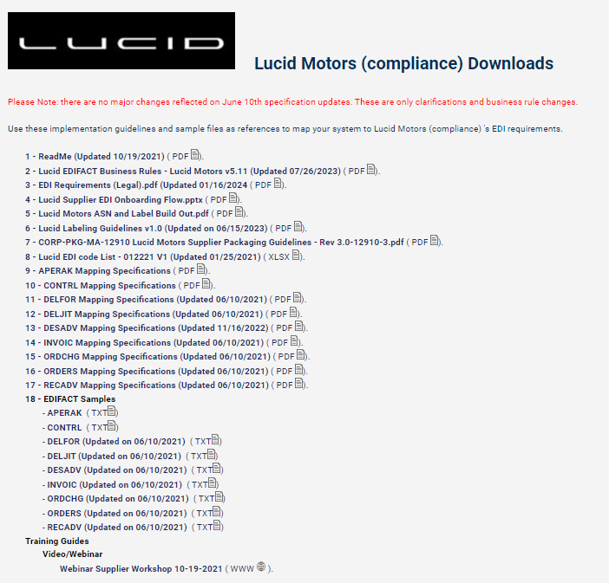
- During onboarding, Suppliers should first email True Auto Onboarding (TrueAuto.Onboarding@truecommerce.com). Once onboarded, contact True Auto Support (TrueAuto@truecommerce.com) for any issues related to portal processing. Before you do, please review the readily available help button on the portal. Keep your GSM, Material Planner and Lucid EDI copied on all onboarding activities so we can track progress towards meeting a successful Gravity onboarding.

